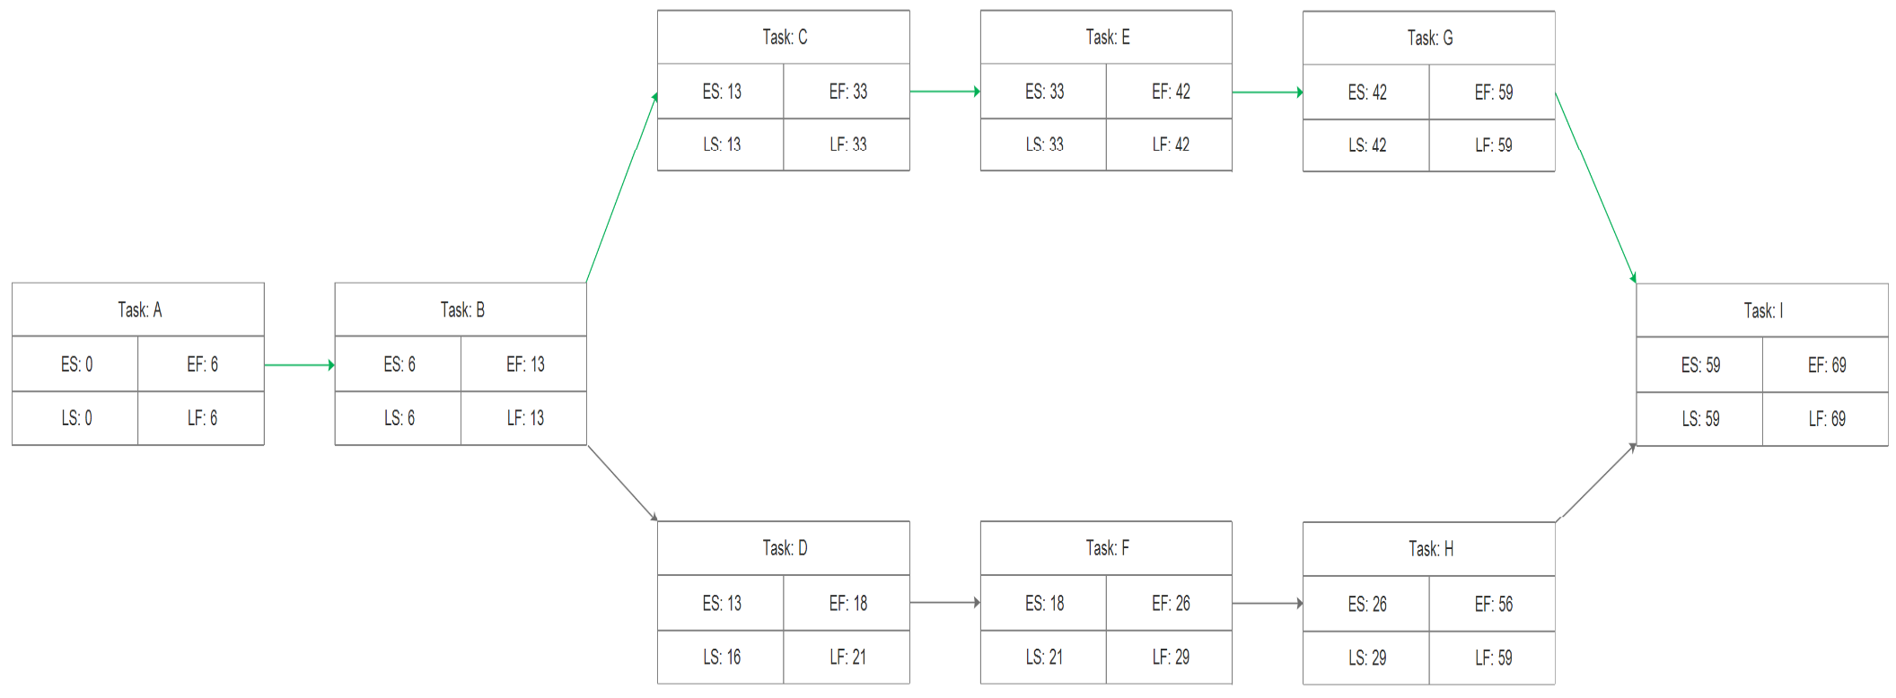

Figure 6: PERT Chart

Where in:

|  |  |  |  |
| --- | --- | --- | --- |
| Tasks | Task Description | Duration (Days) | Predecessor |
| Task A: | Scope Definition | 6 | None |
| Task B: | Problem Analysis Phase | 7 | A |
| Task C: | Requirements Analysis Phase | 20 | B |
| Task D: | Logical Design Phase | 5 | B |
| Task E: | Decision Analysis Phase | 9 | C |
| Task F: | Physical Design Phase | 8 | D |
| Task G: | Prototyping Phase | 17 | E |
| Task H: | Construction and Testing Phase | 30 | F |
| Task I: | Installation and Delivery | 10 | G, H |

Possible Paths: A + B + C + E + G + I = 69 days

A + B + D + F + H + I = 66 days

Critical Path: A + B + C + E + G + I = 69 days